Go to Expeditor and give Listing option LL

Or

Go to the compilation step of the COBOL program

**F HEXLOC** in the listing then look for offset there

Now say the Offset is 1B804BF0 then search with the offset 1B804BF0 in the listing.

If you find the code then that is the point of abend say SOC7

If you don’t find the exact offset try searching by removing starting characters say F 4BF0

Another option is going to the CEEDUMP and directly find for 1B804BF0 then you will find another offset there say +00004080.

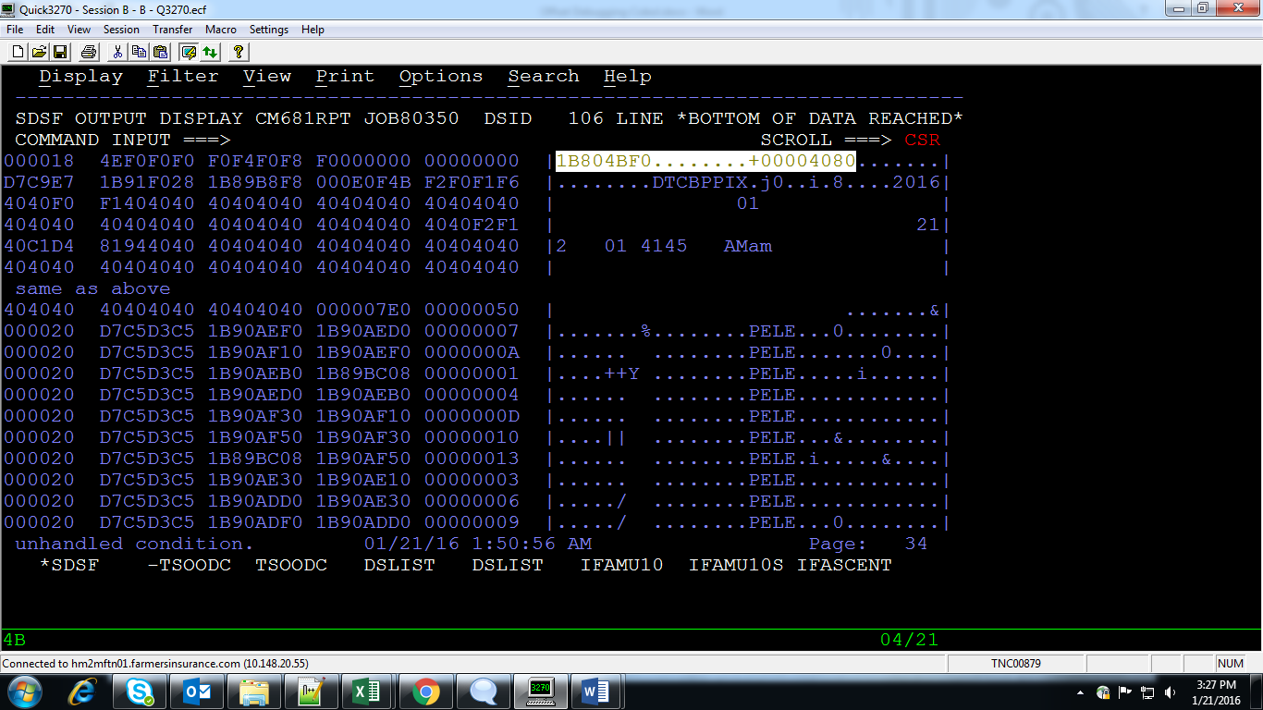

Now go to the listing and find hexloc

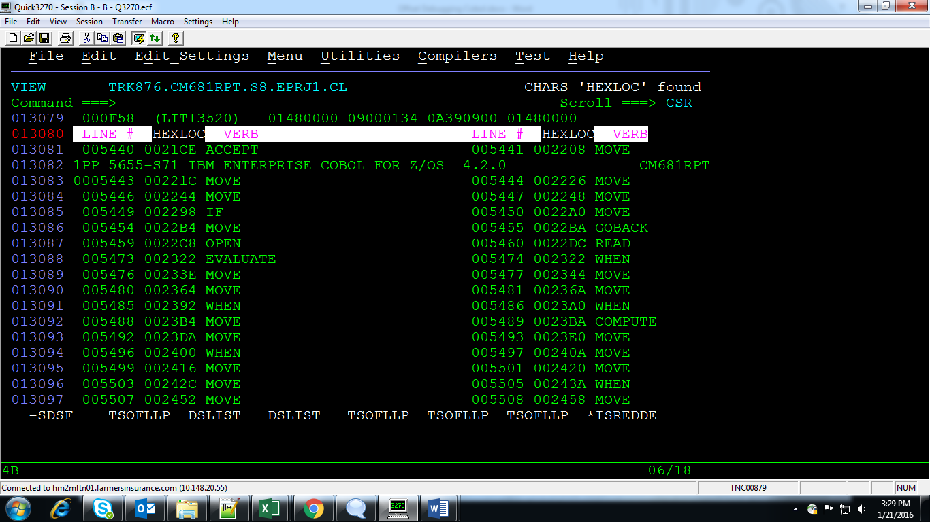

Now look for offset near 4080 and find the corresponding line no

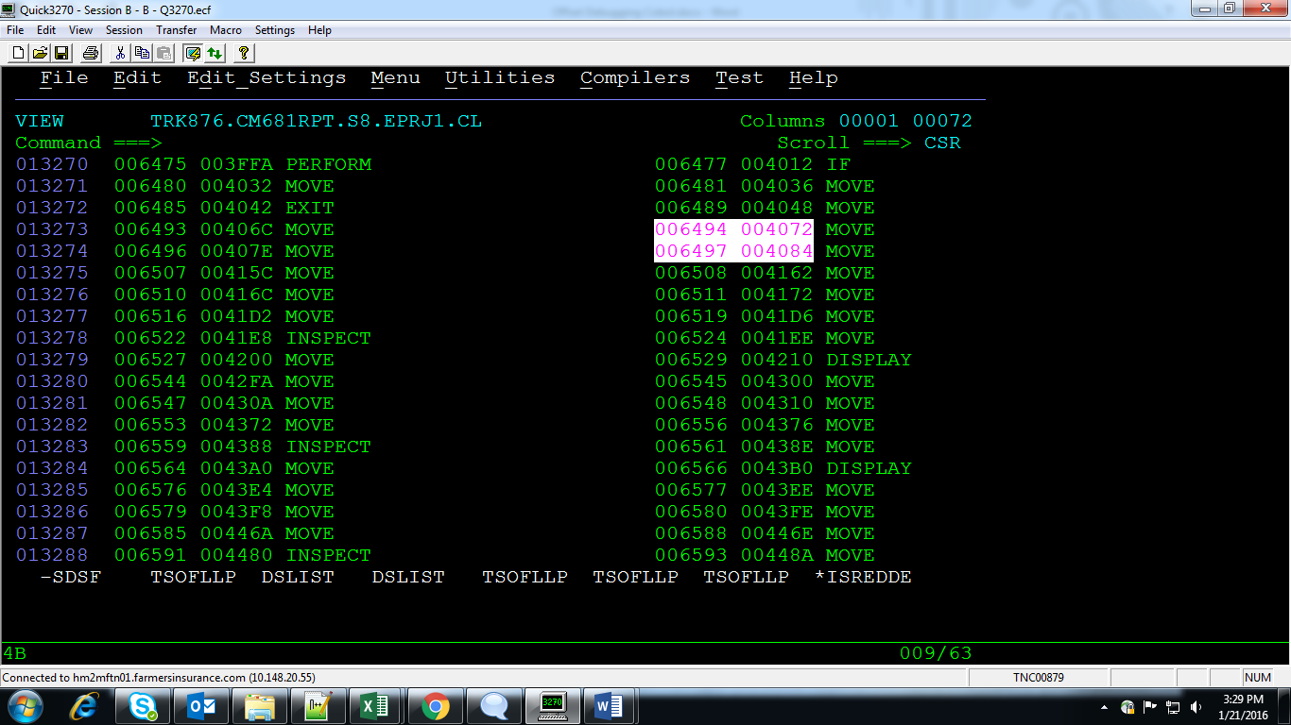

Now your error location is between line no’s 6494 and 6497

Now search for line no **F 6494**

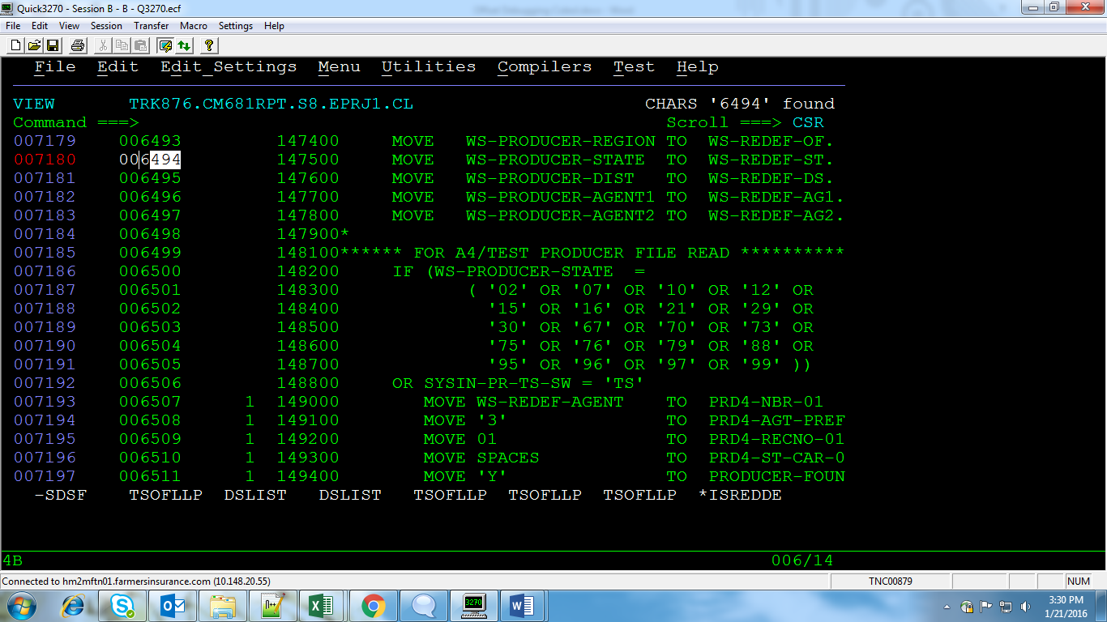

NOW finally read above 100 lines and below 100 lines to be sure of the error location

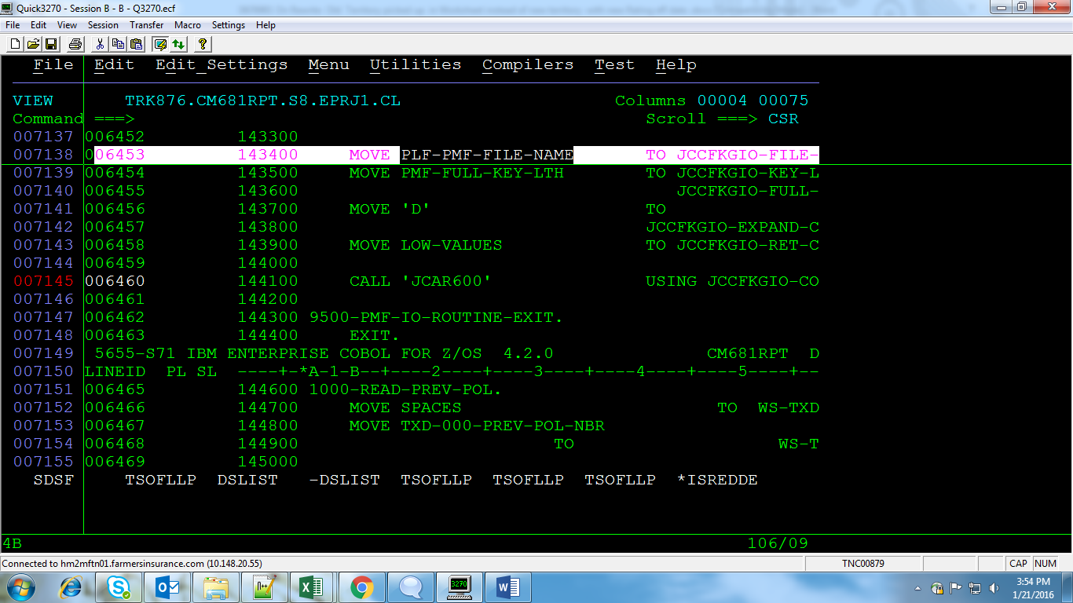

Found the exact issue @ line 6453